Assessment: In-Lab Exercise 01
Student Name: Vasukumar Patel
Lab Professor Name: James Mwangi
Lab Section Number: 343
Due Date: September 17th

Task 1

Step-2
I found the logic error in “ rectanglePerimeter= 2 * length + width “. There is no brackets. So, it will multiply the length and then the value will add into width. So, the answer is wrong, but it will display a wrong answer.
The right one is this : rectanglePerimeter = 2 * (length + width)

Step-3
Start
Declarations
num length
num width
num rectangleArea
num rectanglePerimeter
output “Enter length of the rectangle”
input length
output “Enter width of the rectangle”
input width
rectangleArea = length*width
output “The area of rectangle =”, rectangleArea
rectanglePerimeter = 2* length + width
output “The perimeter of rectangle =”, rectanglePerimeter
Stop

Task 2

Start
Declaration
num number1
num number2
num modulus
num product
output “Enter number1”
input number1
output “Enter number2”
input number2
modulus = number1 % number2
output “the answer of modulus =”, modulus
product = number1 * number2
output “the answer of product =”, product
Stop

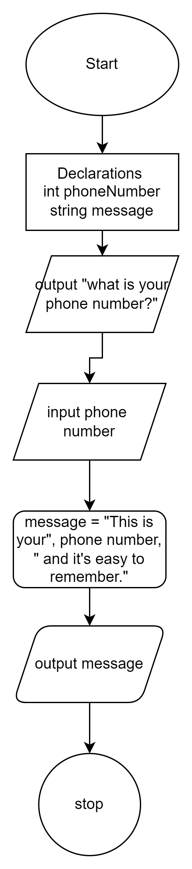

(Task - 3)

References / Sources Cited (optional section as needed)

